

**Headquarters**

88 University Street Belfast BT7 1HE Northern Ireland

Telephone(0232)324274 Facsimile (0232)333147

24 April 1991,

M S Fielding, Town Clerk, Lisburn Borough Council, Borough Offices, The Square, HILLSBOROUGH, BT26 6AH.

Dear Mr Fielding,

You were kind enough to send to me details of the welcome given by the Council to the Brooke Initiative.

I would be grateful if you would convey to the Council at its next meeting my thanks for their good wishes. I would wish the Council to be assured that I and my colleagues are making the success of these negotiations a personal and political priority of the highest order.

I would also welcome the Council's continued and prayerful support of the process.

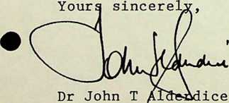

PARTY LEADER