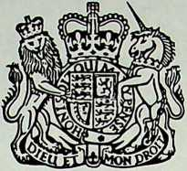

NORTHERN IRELAND

Information Service

29 April 1992

TALKS STATEMENT

The new political talks which started on 9 March this year resumed today. All the participants reaffirmed their icommitment to the talks on the basis of the then Secretary of State's statement of 26 March 1991.

The Secretary of State held an introductory meeting with the four party leaders together.

There was a meeting in plenary session, in which the Secretary of State and each of the four party leaders made opening statements.

The Business Committee, under the Chairmanship of Mr Hanley, will hold a meeting this afternoon to assist in the planning of the forthcoming work.

There will be further meetings, including including further plenary discussions, next week.